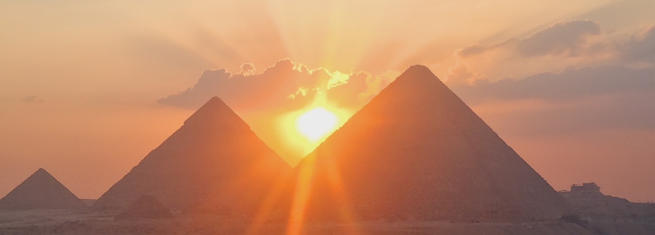
Egypt 20th to 26th March 2023
Initiatic Path to New Beginnings

Thank you for finding your way here.
We hope that If you feel it in your heart and in your soul, that you are able to join us In March. It is our absolute privilege to accompany you on this journey of a lifetime.

Egypt is as multi-layered, multi-faceted and multidimensional as our understanding of
consciousness.

There are keys, codes and activations here which begin to awaken within ourselves, memories of the truth of who we are.

Science is only now beginning to understand the ancient wisdom and forgotten knowledge hidden in this timeless place.

Join us on a powerful journey of transformation and as we explore beyond the known and connect with the remembrance of powerful vibrational technologies and hidden knowledge held within the Sacred Sites in this Ancient Land.

Workshops will include hypnosis, breathwork sessions and the use of the Lucia. No.3 (a neurostimulator which induces a hypnagogic trance by activating the pineal gland through specific frequencies of light) to assist in accessing expanded states of awareness, deep intuition, insights and breakthroughs.

This is an intuitively crafted journey for anyone ready for an adventure of deep transformation and insight. We have kept the group small and intimate to facilitate individual space for everyone’s development in a safe and sacred space. We will be visiting secret and sacred places usually inaccessible to usual tourists. This is a journey of the soul toward its own Remembrance.

We have specifically chosen powerful dates for this journey including a private Visit to the Kings Chamber in the Great Pyramid of Giza on the 21st March.

On the 21st March 2023 is the start of the Astrological New Year, with A New Moon in the first degree of Aries marking the beginning of a powerful new cycle, on an individual and global level. The Great Pyramid of Giza being the representation of the Earth's axis, amplifies the energy of new cycles and new beginnings, allowing us to access this powerful shift in energy and embody it within our own being.

The New Moon in Aries marks the beginning of a new cycle
This New Moon occurs in the very first degree of Aries (and the zodiac), suggesting a particularly strong new beginning theme globally.

Itinerary

20th March Check In Turquoise Pyramid View Hotel – Giza
We would like to start our adventure at 12.00
Afternoon welcome and sunset at the Pyramid View Terrace with a light
dinner.
21st March Private Visit Pyramid 3am to 5am
Meet at 2.00am outside Turquoise Pyramid Hotel
7.00 am – 9.am Giza Plateau and Sphynx general visit
Workshop
Abu Gurab Activation (sunset)
22nd March Early Morning Pyramid Visit
Saqqara / Bent Pyramid / Red Pyramid / Serepium
Desert trip with Oscar- camel/gorse ride and light dinner.
23rd March Early Morning Pyramid Visit
Check out and leave for Valley of Whales
Lunch at Valley of Whales
Transfer to Cairo Airport
Flight Cairo to Luxor
Check in Hilton Hotel
Dinner
24th March Early morning Karnak Temple
Return to Hotel for Breakfast
Workshop Hilton Hotel
Luxor Temple
25th March Depart Early for Dendara and Abydos
Dinner and Debrief at Hilton
26th March Hot Air Balloon Ride Over the Nile and Valley Of Kings
Return to Hotel
Final Breakfast and Closing
Trip End

Meals included: All breakfasts, Two light dinners and one lunch.

Preparation and Integration
In order to benefit the most from this Journey, we invite you to join us 4 weeks before we arrive in Egypt for weekly live zoom chats in preparation for our trip. Here we will be sharing information about each of the sacred sites we will be visiting, setting intensions for our own personal self-development and inner journeys. We will also share breathwork and Hypnotherapy sessions, beginning to fine-tune our intuition and access to own inner wisdom.

We will also offer weekly meetings for four weeks after our trip which will serve as integration and a safe space in which to share any insights that may come up after the journey.

Facilitators
Andrea Kellerman
B.A., H.E.D., B.A. Hons. Psych., M.Ed Psych., Dipl.Adv. Hyp., ISNR registered Neurofeedback Practitioner. (Prac. No. PS0115207 and SAMHF 791953)

Andrea Kellerman is a registered Educational Psychologist who has been working with children and adults for the past 25 years. She has formerly worked as a qualified teacher and has lectured and taught children and adults at school, college and university level. After having studied psychology, hypnotherapy and neurofeedback/brain training, she worked in hospitals, a crisis centre and private practice where she has helped many people who suffer from anxiety, depression, stress, insomnia, eating disorders, concentration problems, ADD/ADHD, people who needed to stop smoking, lose weight and reduce phobias.

Andrea follows a holistic approach when working with clients. She has completed DNA, functional medicine courses, is always increasing her knowledge in neuroscience, transformational treatments and uses the latest therapy techniques to help her clients in the best and most effective way possible

Lisa Armstrong
With an innate quest for truth and authenticity, Lisa never resonated with the old paradigm.
With a financial career abandoned, she was drawn to the simple truth of nature. The magnetic call of the ocean lead the path to a career in Scuba Diving and a deep desire to share a different perspective of life with others. Nature has a way of uncovering our truths.
After building and operating an Eco-Lodge in Mozambique, her passion for exploring and understanding the frontiers of human consciousness drew her on a path of self-discovery, studying Yoga ,Kinesiology, Psych-k, Quantum Healing Hypnosis, Fractal Psychology, Neurodynamic Breathwork, Plant Medicines, Bio-geometry, with a passion for learning more about the ever-expanding fields of Quantum Physics, Unified Science and Neuroscience.

More recently, she has spent a large part of the last two years in Egypt with Mathias De Stephano and studying under Dr. Ibrahim Karim learning about the ancient, hidden vibrational and temple science that is encoded sacred sites.

Lisa has an intuitive understanding that we each are gifted with the potential to be anything, do anything, without exception. She provides a safe space and skills in which to break through the boundaries of the conditioned human mind allowing access to greater levels of human potential that are dormant within each human heart and mind.

Testimonial

'Why I had such a strong pull to join this adventure in Egypt I did not fully comprehend at the time.

Fortunately I listened to my heart and went on a journey in which the alchemy of connection turned worldly experience into spiritual treasure. Mutual curiosity and attraction to the unknown made this group unique.

Every person there unconditionally supported the other and allowed space to connect in an authentic way without judgement. We were keenly aware of the incidental connection and meaning between the physical events playing out on this journey and the inner experiences we were having.

We visited many pyramids and sacred sites where the timeless energies of potential and possibilities are still present in the ancient remains of the past. Through this amazing journey I learned to connect more with myself and my feelings, knowing that all experiences are there to support me, helping me to detach from expected outcomes.

As I ventured deeper and climbed into the dark, quiet sarcophagus of my being, I experienced the stillness not as lonely isolation, but a peaceful at oneness with all existence.
A journey of remembrance worth taking.'

Helga 11.11.2022

Investment
Inclusions:
- Meet and Greet at Cairo International Airport
- Transfer from Cairo International Airport to Giza Turquoise Pyramid View Hotel
- 3 Nights Accommodation at Turquoise Pyramid View Hotel Including Breakfast
- 2 hour Private Visit to the Kings Chamber on the 21st March
- Roof top Sunset and Local Egyptian Dinner on the 20th March (including transfers)
- Private Visit to Abu Gurab (Sundisk) including transfers
- Trip to Saqqara / Serapium / Red Pyramid / Bent Pyramid including transfers
- Trip to Valley Of Whales Including Return Transfers / Lunch and Entrance Fees
- Camel ride in the desert for Sunset including Transfers and dinner
- Transfer to Cairo International Airport
- Internal Flight from Cairo to Luxor
- Transfer from Luxor International Airport to Hilton Hotel Luxor
- 3 nights Accommodation at Hilton Hotel Including Breakfast
- Visit to Kanak Temple
- Day trip to Dendera / Abydos and Osirian Temple including transfers
- Visit to Luxor Temple
- Hot Air Balloon Ride over the Nile River and Valley Of Kings
- All Workshops: Group Neurodynamic Breathwork / Lucia Light #3 Pineal Gland Activation / Group Self Development and Coaching / Group Hypnotherapy Sessions
- 4 Preparation Online Live Workshops
- 4 Integration Online Live Workshops

Exclusions:
- International Flights
- Egyptian Visa If Required
- Return Flight from Luxor to Cairo
- Travel Insurance
- Travel / Medical Insurance
- Most Lunches and Dinners will be for your own account
- Entrance Into Giza Plateau and Pyramid on the 22nd and 23rd (Optional)
- Tips
- Shopping
- SIM card
- Any other extras of a personal nature

Early Bird Price:
USD 2222 – (Per Person Sharing)

Medical aid rates apply as well for sessions during the workshop time. Please enquire if you want to use your medical aid.

50% deposit payable before 01st February 2023
Remainder of payment due on the 01st March 2023

Normal Price:
USD 2444 – (Per Person Sharing)
Full payment required by 01st March 2023

Single Supplement:
If you would prefer a single room, please add on USD 365. If you are coming alone and would like to share, we can try to pair you with someone else on the trip
Additional Info:
Please check what Visa requirements into Egypt are for your country
Please bring a copy of your passport with you
The hotels we are staying at do have WIFI but it is also recommended to get yourself an Egyptian SIM card with data of you need to be connected
Egyptian SIM cards are available at the airport
If you are wanting Egyptian pounds, there is an exchange at the airport alternatively it is possible to change USD or Euros into Egyptian pounds at the hotel opposite where we are staying. It is also easy to draw local currency from the ATM.
Should you wish to arrive earlier or stay later, we can refer you to an agent who can assist you with your booking.

